 | Guide for using Packer + Terraform with Huawei Cloud.
 | Issue | 01
 | Date | 2023-10-23

 | Huawei Technologies Co., Ltd. |  | 

Copyright © Huawei Technologies Co., Ltd. 2023. All rights reserved.
No part of this document may be reproduced or transmitted in any form or by any means without prior written consent of Huawei Technologies Co., Ltd.

Trademarks and Permissions
 and other Huawei trademarks are trademarks of Huawei Technologies Co., Ltd.
All other trademarks and trade names mentioned in this document are the property of their respective holders.

Notice
The purchased products, services and features are stipulated by the contract made between Huawei and the customer. All or part of the products, services and features described in this document may not be within the purchase scope or the usage scope. Unless otherwise specified in the contract, all statements, information, and recommendations in this document are provided "AS IS" without warranties, guarantees or representations of any kind, either express or implied.
The information in this document is subject to change without notice. Every effort has been made in the preparation of this document to ensure accuracy of the contents, but all statements, information, and recommendations in this document do not constitute a warranty of any kind, express or implied.

Huawei Technologies Co., Ltd.
Address: | Huawei Industrial Base Bantian, Longgang Shenzhen 518129 People's Republic of China
Website: | https://www.huawei.com/en/
Email: | support@huawei.com

Contents
1 Best Practices 4
1.1 Solution Overview 4
Resources and Prices 6
1.2 Installing Packer on the local machine. 7
1.3 Generating Template file for preparing image. 7
1.4 Create the image using the template 8
1.4.1 Creating a Variable file for the template. 10
1.4.2 Building the Template. 10
1.5 Using Terraform to create ECS using the generated image from Packer. 12
1.5.1.1 Creating the Terraform Script 13
2 Appendix 18
2.1 Source Code 18
2.1.1 versions.tf 19
2.1.2 terraform.auto.tfvars 19
2.1.3 main.tf 20
20
# Defining variables for Region, and AK/SK.
variable "access_key" {
type = string
default = null
}

variable "secret_key" {
type = string
default = null
}

variable "region" {
type = string
default = null
}

# Configure the HUAWEI CLOUD provider.
provider "huaweicloud" {
region = var.region
access_key = var.access_key
secret_key = var.secret_key
}

# Create a VPC
resource "huaweicloud_vpc" "example" {
name = "terraform_vpc"
cidr = "192.168.0.0/16"

}

# Creating a subnet inside the VPC
resource "huaweicloud_vpc_subnet" "subnet-example-tf" {
name = "subnet-terraform"
cidr = "192.168.1.0/24"
gateway_ip = "192.168.1.254"
vpc_id = huaweicloud_vpc.example.id
}

data "huaweicloud_availability_zones" "myaz" {}

data "huaweicloud_compute_flavors" "myflavor" {
availability_zone = data.huaweicloud_availability_zones.myaz.names[0]
performance_type = "normal"
cpu_core_count = 1
memory_size = 2

}

resource "random_password" "password" {
length = 16
special = true
override_special = "!@#$%*"
}

resource "huaweicloud_compute_instance" "basic" {
name = "basic"
admin_pass = random_password.password.result
image_id = #TYPE YOUR IMAGE ID HERE
flavor_id = data.huaweicloud_compute_flavors.myflavor.ids[0]
availability_zone = data.huaweicloud_availability_zones.myaz.names[0]
security_group_ids = #TYPE YOUR SG ID HERE

network {
uuid = huaweicloud_vpc_subnet.subnet-example-tf.id
}

}

A Change History 21

Best Practices

Solution Overview
Applicable Scenarios
Deploying multiple ECS with the similar configurations can become a tedious, repetitive and long task.
- Manually deploying ECS through the console is a very repetitive task, and can become prone to human error while selecting specifications, and other configurations through the console.
- Using the console alone does not allow a task to be automated, so when more than one ECS needs to be created at a time it becomes a slow process.
This section describes and explains how to use the Huawei Cloud Packer plugin, along with Terraform in order to deploy ECS on Huawei Cloud.
Architecture
This section describes the principles and practices of using packer templates and Terraform.
Packer is an open source tool for creating identical machine images for multiple platforms using a single source configuration. Packer is a lightweight, and runs on every major operating system, and is highly performant. Capable of creating machine images for multiple platform in parallel.
Packer does not replace configuration management tools, instead it can use them to install software onto the image.
According to the Packer Documentation a machine image is a single static unit that contains a pre-configured operating system and installed software which is used to quickly create new running machines.
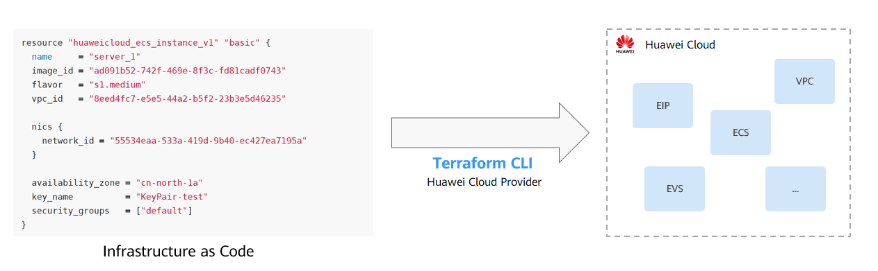
Figure 1. Using Terraform to manage cloud resources.
Terraform is an open-source tool used to orchestrate and manage IT infrastructure. You can describe an application or entire data center in configuration files. Terraform is used to easily create, manage, delete and version cloud resources on HUAWEI CLOUD.

In this guide we will base on the following architecture. First using Packer to create an image and then using the created image with Terraform to deploy ECS with code.

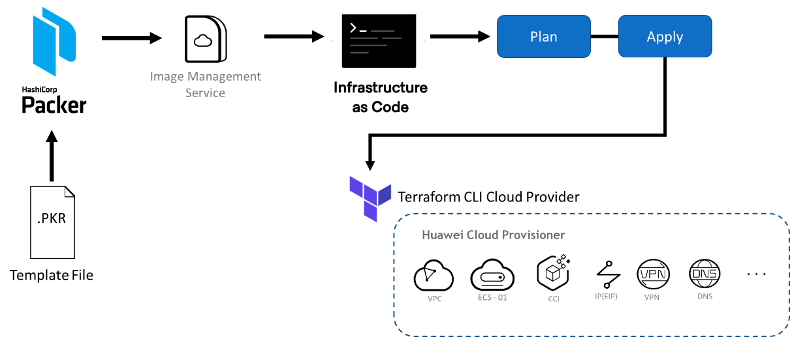

Highlights
- Lightweight, Opensource, multiplatform.
- Using a single configuration file for multiple images.
- Create ECS for multiple platforms in Parallel.
Constraints
- Terraform manages the state of the resources. If they get changed from other sources such as the Huawei Cloud console, this will make the configuration file not match reality. Which in turn makes management or modifying resources more challenging within Terraform

Resources and Prices
                - Resources and prices
Region | Resource | Resource Name | Description | Quantity | Monthly Cost (USD)
LA-Mexico City2 | Virtual Private Cloud (VPC) | Generated Automatically | CIDR block: 10.0.0.0/16 | 1 | 0.00
LA-Mexico City2 | VPC subnets | Generated Automatically | CIDR block: 10.0.1.0/24  Local subnet for establishing a Layer-2 connection to the remote subnet. This subnet is where the ECS is located. | 1 | 0.00
LA-Mexico City2 | Elastic Cloud Server (ECS) | ecs-packer | Flavor: s6.large.2  System Disk: 40 GB | 1 | 104.17
LA-Mexico City2 | Image Management Service | Ubuntu-2022-ProvidedByPacker | The image generated by packer which gets uploaded on IMS | 1 | 0.00

The estimated resource cost is 104.17 USD, excluding the fees generated during host migration. For details about the migration fees, see Pricing Details.


The prices provided here are for reference only. The actual prices are shown on the Huawei Cloud console.

Installing Packer on the local machine.
Either inside an ECS or a local machine you can download and install packer, access the download page of the product through this link. Hashicorp Packer Download.
As Packer is a multiplatform program, select the version appropriate to your OS. In this document will follow installation as if using a Windows Machine.
Step 1 Enter the download link.
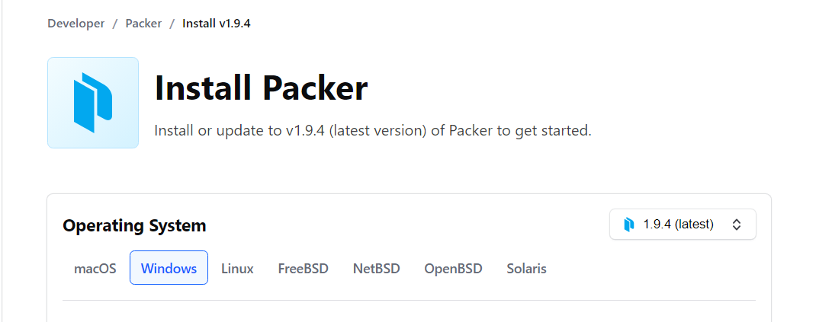
Step 2 Unzip the downloaded file onto a folder.

Generating Template file for preparing image.
To create an image using Packer a template in the format .pkr.hcl format. Inside the template you need to configure builders, provisioners, and post-processors.
In providers, you can modify the source image as you need. For example, modify configurations and specify the software to be pre-installed.
In the GitHub repository of the plugin, you can find the required parameters for building your template file.
The resulting image from the packer template will be available in Image Management Service and will be used by terraform when creating multiple ECS in parallel.
Here is also an example template:
packer {
required_plugins {
huaweicloud = {
version = ">= 1.0.0"
source = "github.com/huaweicloud/huaweicloud"
}
}
}

source "huaweicloud-ecs" "artifact" {
region = "xxx"
availability_zone = "xxx"
flavor = "c6.large.2"
source_image_name = "Ubuntu 22.04 server 64bit"
image_name = "Ubuntu-2204-image-powered-by-Packer"
image_tags = {
builder = "packer"
os = "Ubuntu-22.04-server"
}

ssh_username = "root"
eip_type = "5_bgp"
eip_bandwidth_size = 5
}

build {
sources = ["source.huaweicloud-ecs.artifact"]

provisioner "shell" {
inline = ["apt-get update -y"]
}

post-processor "manifest" {
strip_path = true
output = "packer-result.json"
}
}

When using this template do not forget to set the following parameters: region, availability zone

Create the image using the template
If it is the first time running the packer template with the Huawei plugin, it is necessary to initialize the plugin first. This is done by running the following command.
$ packer init hwcloud.pkr.hcl
The output of previous command should look like above.
Validate if your template does not have any errors or missing parameters by running the validate command
$ packer validate hwcloud.pkr.hcl
Running the command without changing anything on the template will generate the following error
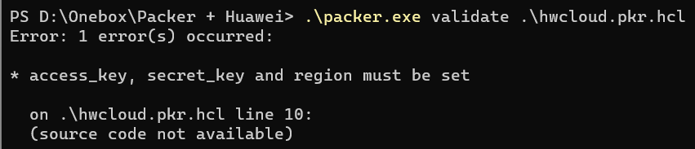
Modify the template to add the following lines below the packer field in the file.
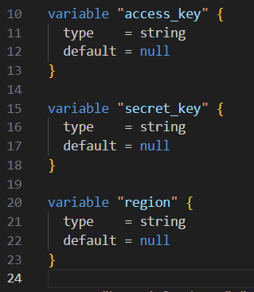
Also add the following lines below the source field in the file.
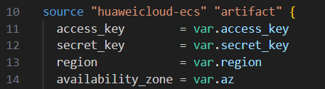

Creating a Variable file for the template.
In order to fix the previous error, it is needed to specify your Access Key and Secret Access Key in the Packer Template script, but it is not a good practice to include the keys in the template as they will be stored as plaintext. Sharing this template will expose your AK/SK to the public where bad actors could use the keys to have access to your resources on the cloud.
The Variable file can look like this:
access_key = "TYPE YOUR AK HERE"
secret_key = "TYPE YOUR SK HERE"
region = "SPECIFY A REGION" --ex: la-south-2

You can check the region names and endpoints here.
A variable file is only to be used on locally in the machine that is going to run the build command and is formatted as in terraform.

Building the Template.
Now it will be possible to run the build command to generate the image by adding the -var-file flag.
Step 1 Execute the following command. To validate if the template is correctly configured.
$ packer validate hwcloud.pkr.hcl -var-file=”variables.pkrvars.hcl”
You can avoid to pass the file via command line by renaming the file to anything that matches the expression: *.auto.pkrvars.hcl, then you can simply call with:
$ packer validate .

Do not skip the “. “ at the end of the command.
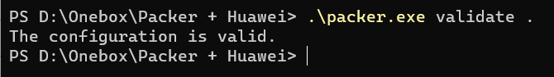
Step 2 After configuration is valid, then you can run the following command to build the image.
$ packer build hwcloud.pkr.hcl -var-file=”variables.pkrvars.hcl”
Using the *.auto.pkrvats.hcl
$ packer build .

Step 3 Validate results.
A successful execution will show the following:
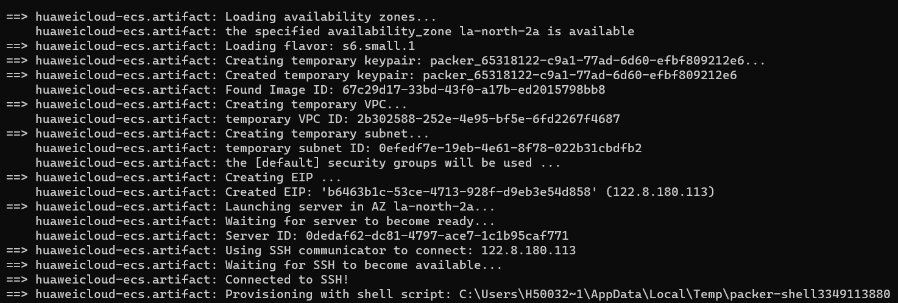

After finishing the script will inform if either success of failure happened.
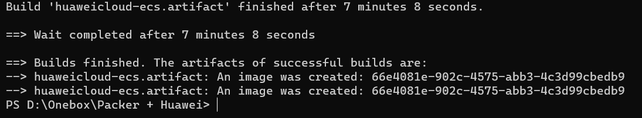
Step 4 From the console head to the Service List > Compute > Image Management Service
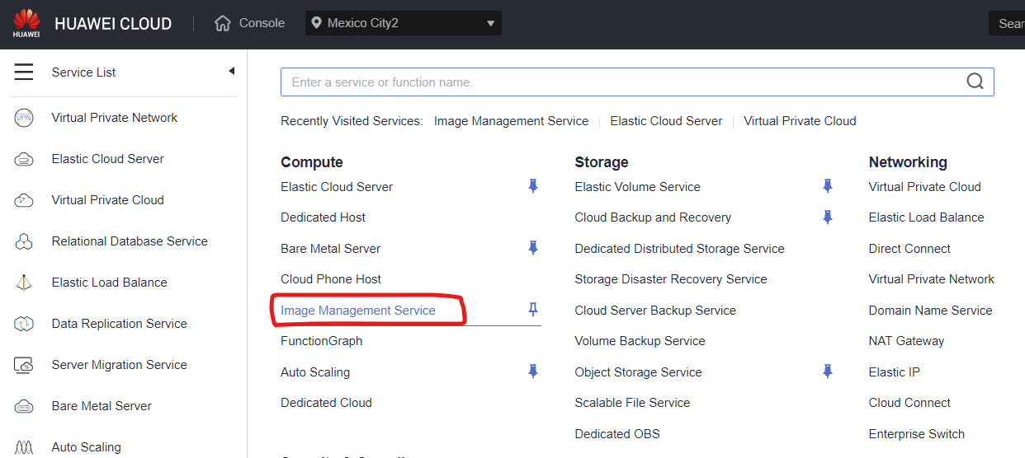

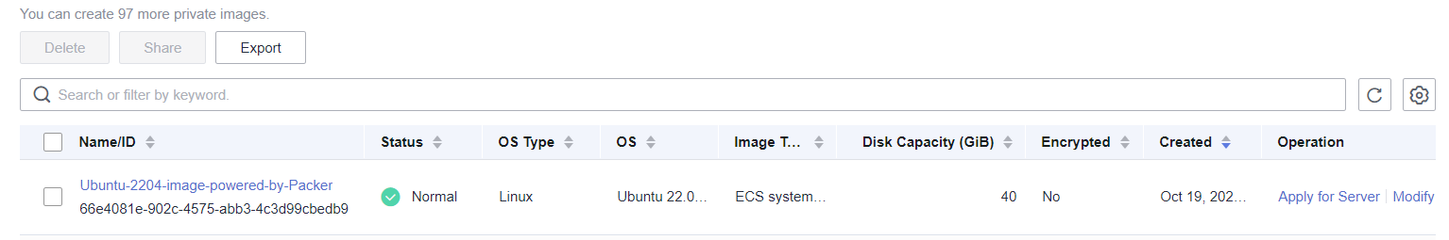

This new image can now be used to generate new ECS, through Terraform. Details on how that can be done will be described on the next section.

Using Terraform to create ECS using the generated image from Packer.
Either inside an ECS or a local machine you can download and install terraform, access the download page of the product through this link. Hashicorp Terraform Download.
As Terraform is also a multiplatform program, select the version appropriate to your OS. In this document will follow installation as if using a Windows Machine.

Step 1 Enter the download link for your appropriate platform.
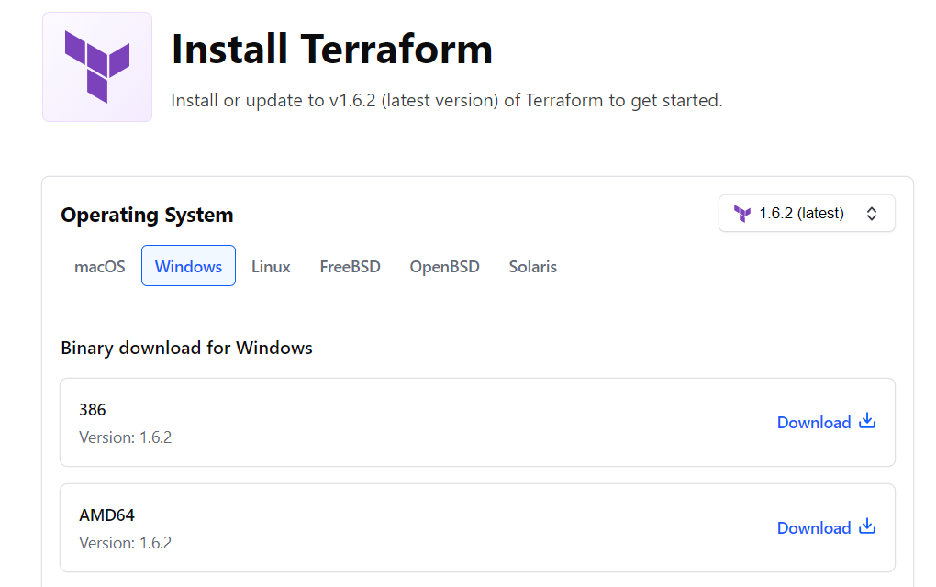
Step 2 Unzip the downloaded file.
Step 3 Add the Terraform package to path (Optional)
Step 4 Validate install by running the following command.
$ terraform -v
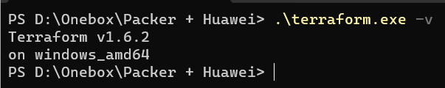

Creating the Terraform Script
Just as packer, terraform scripts are written in HCL or optionally in JSON and their extension is “.TF”, It is structured by blocks. In the next steps we will generate a template for using Terraform with Huawei Cloud.
Two files need to be generated when using terraform, the versions.tf and main.tf
Step 1 Create the file versions.tf with the following information.
terraform {
required_providers {
huaweicloud = {
source = "huaweicloud/huaweicloud"
version = " >= 1.20.0"
}
}
}

Step 2 Create the main.tf file to configure the HUAWEI CLOUD provider.
# Defining variables for Region, and AK/SK.
variable "access_key" {
type = string
default = null
}

variable "secret_key" {
type = string
default = null
}

variable "region" {
type = string
default = null
}

# Configure the HUAWEI CLOUD provider.
provider "huaweicloud" {
region = var.region
access_key = var.access_key
secret_key = var.secret_key
}

Remember that is unsafe to store access and secret keys as plaintext in code. A similar method can be used as in the packer template to create a variable file which will store the AK/SK without it being embedded in the main script.

Step 3 Assign values to the variables by creating a new file named terraform.auto.tfvars.
access_key ="TYPE YOUR AK HERE"
secret_key ="TYPE YOUR SK HERE "
region ="SPECIFY A REGION" # example: la-south-2

}

Just like with packer, terraform will look for any file that matches the expression *.auto.tfvars, avoiding the use of the -var-file flag.

Step 4 Inside the same file you can start adding resources to be created. First, add the following block to create a VPC.
# Create a VPC
resource "huaweicloud_vpc" "example" {
name = "terraform_vpc"
cidr = "192.168.0.0/16"

}

You can consult all the resources that can be created by checking the Official Huawei Cloud Provider Documentation.
Step 5 Create a subnet for the ECS to attach into
# Creating a subnet inside the VPC
resource "huaweicloud_vpc_subnet" "subnet-example-tf" {
name = "subnet-terraform"
cidr = "192.168.1.0/24"
gateway_ip = "192.168.1.254"
vpc_id = huaweicloud_vpc.example.id
}

Step 6 Query the availability zones and flavors with the following data blocks.
data "huaweicloud_availability_zones" "myaz" {}

data "huaweicloud_compute_flavors" "myflavor" {
availability_zone = data.huaweicloud_availability_zones.myaz.names[0]
performance_type = "normal"
cpu_core_count = 1
memory_size = 2

}

Step 7 Create a random password for the ECS. Using the random_password resource.
resource "random_password" "password" {
length = 16
special = true
override_special = "!@#$%*"
}

Step 8 Create the ECS using the huaweicloud_compute_instance resource block.
resource "huaweicloud_compute_instance" "basic" {
name = "TYPE IMAGE NAME HERE"
admin_pass = random_password.password.result
image_id = "TYPE THE IMAGE ID HERE"
flavor_id = data.huaweicloud_compute_flavors.myflavor.ids[0]
availability_zone = data.huaweicloud_availability_zones.myaz.names[0]
security_groups = ["default"]

network {
uuid = huaweicloud_vpc_subnet.subnet-example-tf.id
}
}

Step 9 Fill the image ID filed with the ID of the recently created image either from the packer output message, or checking from within IMS.

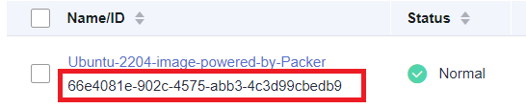

It is also possible to Terraform for querying the image ID with the data source from IMS, please refer to the Official Huawei Cloud Provider Documentation.
Step 10 Execute the following command to validate the resources that are going to be created.
$ terraform plan
After execution you should see this message, as only 3 resources are going to be created.
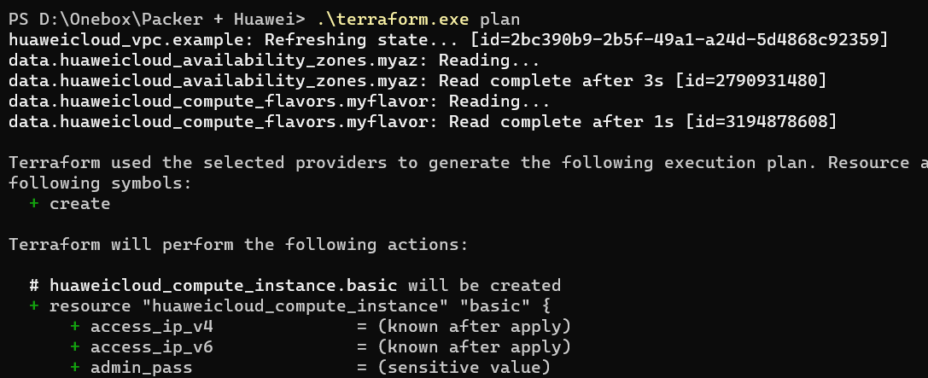

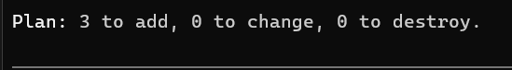

Step 11 Execute the following command to create the resources. When prompted type “yes”.
$ terraform apply
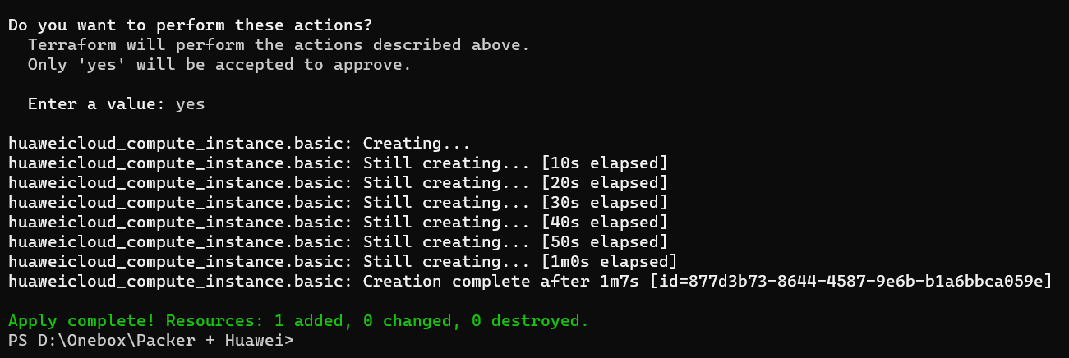
You can now see your recently created ECS in the HUAWEI CLOUD console.
And as you can see it has the specifications described in the terraform script and uses image generated with packer.

Appendix

Source Code

Hwcloud.pkr.hcl
packer {
required_plugins {
huaweicloud = {
version = " >= 1.0.0"
source = "github.com/huaweicloud/huaweicloud"
}
}
}

variable "access_key" {
type = string
default = null
}

variable "secret_key" {
type = string
default = null
}

variable "region" {
type = string
default = null
}

variable "az"{
type = string
default = null
}

source "huaweicloud-ecs" "artifact" {
access_key = var.access_key
secret_key = var.secret_key
region = var.region
availability_zone = var.az
flavor = "s6.small.1"
source_image_name = "Ubuntu 22.04 server 64bit"
image_name = "Ubuntu-2204-image-powered-by-Packer"
image_tags = {
builder = "packer"
os = "Ubuntu-22.04-server"
}

ssh_username = "root"
eip_type = "5_bgp"
eip_bandwidth_size = 5
}

build {
sources = ["source.huaweicloud-ecs.artifact"]

provisioner "shell" {
inline = ["apt-get update -y"]
}

post-processor "manifest" {
strip_path = true
output = "packer-result.json"
}
}

variables.auto.pkvars.hcl
access_key="<AK>"
secret_key="<SK>"
region="<Region Name>"
az="<AZ Name>"

versions.tf
terraform {
required_providers {
huaweicloud = {
source = "huaweicloud/huaweicloud"
version = " >= 1.36.0"
}
}
}

terraform.auto.tfvars
access_key= "<AK>"
secret_key= "<SK>"
region="<Region Name>"

main.tf
# Defining variables for Region, and AK/SK.
variable "access_key" {
type = string
default = null
}

variable "secret_key" {
type = string
default = null
}

variable "region" {
type = string
default = null
}

# Configure the HUAWEI CLOUD provider.
provider "huaweicloud" {
region = var.region
access_key = var.access_key
secret_key = var.secret_key
}

# Create a VPC
resource "huaweicloud_vpc" "example" {
name = "terraform_vpc"
cidr = "192.168.0.0/16"

}

# Creating a subnet inside the VPC
resource "huaweicloud_vpc_subnet" "subnet-example-tf" {
name = "subnet-terraform"
cidr = "192.168.1.0/24"
gateway_ip = "192.168.1.254"
vpc_id = huaweicloud_vpc.example.id
}

data "huaweicloud_availability_zones" "myaz" {}

data "huaweicloud_compute_flavors" "myflavor" {
availability_zone = data.huaweicloud_availability_zones.myaz.names[0]
performance_type = "normal"
cpu_core_count = 1
memory_size = 2

}

resource "random_password" "password" {
length = 16
special = true
override_special = "!@#$%*"
}

resource "huaweicloud_compute_instance" "basic" {
name = "basic"
admin_pass = random_password.password.result
image_id = #TYPE YOUR IMAGE ID HERE
flavor_id = data.huaweicloud_compute_flavors.myflavor.ids[0]
availability_zone = data.huaweicloud_availability_zones.myaz.names[0]
security_group_ids = #TYPE YOUR SG ID HERE

network {
uuid = huaweicloud_vpc_subnet.subnet-example-tf.id
}

}

- Change History
Released On | Description
2023-10-24 | First release. Hugo Juárez Pérez.
2023-11-15 | Format Corrections. Hugo Juárez Pérez

